**8 SCIENCE 2014**

### CHEMISTRY TEST TWO

Name: ____________________ Teacher: ___________________ Mark: /50

**Percentage: %**

**SECTION A: MULTIPLE CHOICE (15 marks)**

**Select the most correct answer for each question below.**

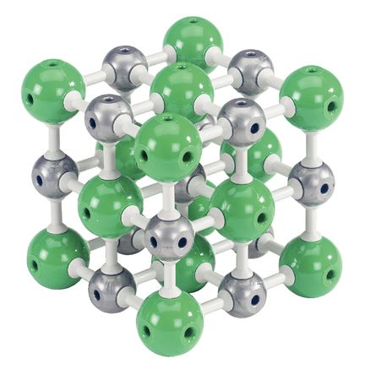

**1.** The model on the right shows an example of:

(a) A carbon lattice.

(b) A crystal lattice.

(c) A crystal lettuce.

(d) A carbon cube.

**2.** A STM is an abbreviation for a special microscope called a:

(a) Spectrum Tunnelling Microscope.

(b) Scanning Telescopic Microscope.

(c) Small Telescopic Microscope.

(d) Scanning Tunnelling Microscope.

**3.** Choose the statement that is true.

(a) Compounds are also elements.

(b) Molecules are also mixtures.

(c) Compounds are also monatomic elements.

(d) Compounds are also molecules.

**4.** Air is an example of:

(a) An element.

(b) A molecule.

(c) A compound.

(d) A mixture.

**5.** Look at the diagram on the right. The diagram shows a:

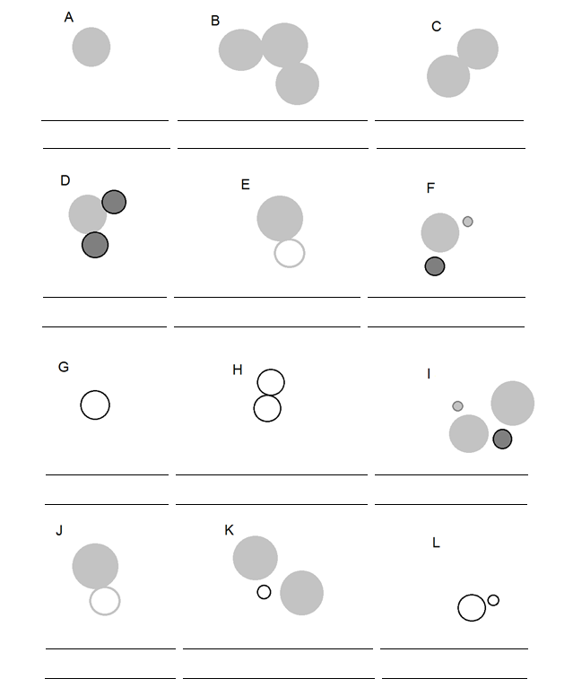

(a) Element and molecule.

(b) Mixture.

(c) Compound and element.

(d) Molecular compound.

**6.** Choose the correct definition for ‘element’.

(a) A substance made up of one type of atom.

(b) A substance made up of more than one type of atom.

(c) The fundamental building blocks of all materials.

(d) The smallest particles that make up everything.

**7.** Look at the diagram on the right. The diagram shows a:

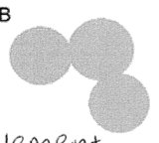

(a) Molecule.

(b) Element and molecule.

(c) Molecule and compound.

(d) Compound and element.

**8.** Choose the correct definition for ‘miscible’.

(a) Liquids that do not mix together.

(b) A gas and liquid that do not mix together.

(c) Liquids that can be mixed together.

(d) A solid and liquid that can be mixed together.

**9.** If a substance is a poor conductor of electricity, this means that:

(a) The substance does not allow heat to pass through it.

(b) The substance does not allow electricity to pass through it.

(c) The substance allows heat to pass through it.

(d) The substance allows electricity to pass through it.

**10.** Look at the diagram on the right. The diagram shows a:

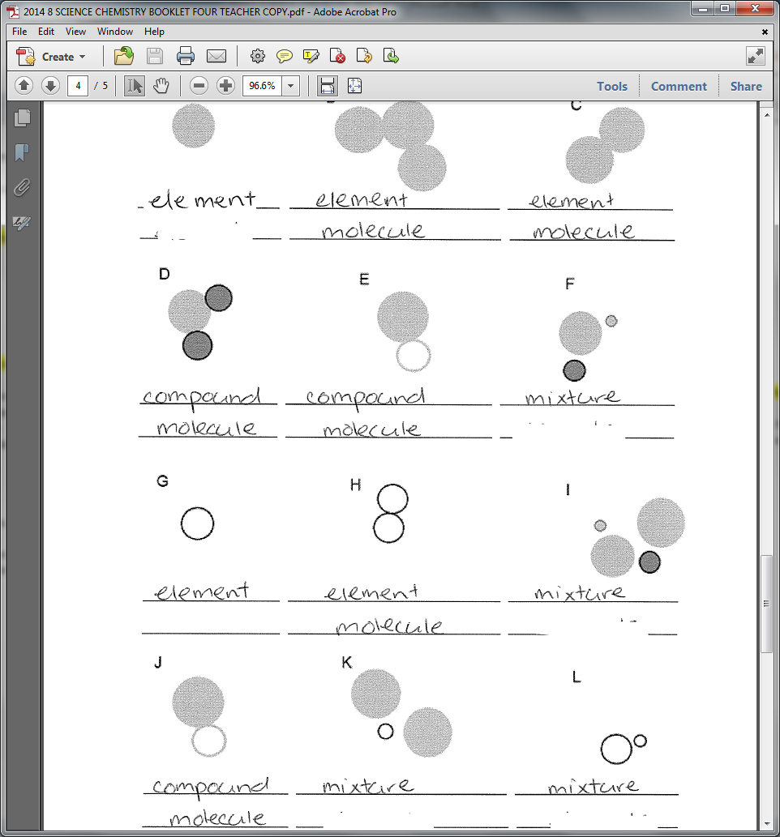 (a) Compound and mixture.

(b) Molecular compound.

(c) Mixture.

(d) Element and mixture.

**11.** Choose the correct definition for ‘brittle’.

(a) Can be bent or stretched.

(b) Breaks or crumbles when bent.

(c) Substances that are not shiny.

(d) Can be stretched into wires.

**12.** How many known elements are there that occur naturally?

(a) 118.

(b) 84.

(c) 92.

(d) 91.

**13.** Choose the correct definition for ‘properties’.

(a) The characteristics of a substance.

(b) The physical structure of a substance.

(c) The fundamental building blocks of all materials.

(d) The appearance of a substance.

**14.** How many known elements are there?

(a) 118.

(b) 92.

(c) 121.

(d) 117.

**15.** Choose the correct term for the definition: ‘can be bent or hammered into sheets’.

(a) Mouldable.

(b) Malleable.

(c) Bendable.

(d) Ductile.

**SECTION B: SHORT ANSWER (35 marks)**

**1.** List four properties of metals. (2 marks)

_____________________________________________________________________________________

_____________________________________________________________________________________

_____________________________________________________________________________________

**2.** List four properties of non-metals. (2 marks)

_____________________________________________________________________________________

_____________________________________________________________________________________

_____________________________________________________________________________________

**3.** Explain the main difference between an element and a compound. (2 marks)

_____________________________________________________________________________________

_____________________________________________________________________________________

_____________________________________________________________________________________

_____________________________________________________________________________________

**4.** Explain the main difference between a mixture and a compound. (2 marks)

_____________________________________________________________________________________

_____________________________________________________________________________________

_____________________________________________________________________________________

_____________________________________________________________________________________

**5.** State the name of the only metal element that is liquid in room temperature. (1 mark)

_____________________________________________________________________________________

**6.** State the name of the only non-metal element that is liquid in room temperature. (1 mark)

_____________________________________________________________________________________

**7.** Stainless steel is a mixture of a metal with other metals. (1 mark)

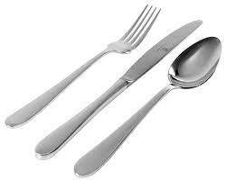Cutlery is usually made from stainless steel.

Stainless steel is an example of a/an: _____________________________

**8.** Write a definition for the word ‘monatomic’. (2 marks)

_____________________________________________________________________________________

_____________________________________________________________________________________

**9.** Write a definition for the word ‘ductile’. (2 marks)

_____________________________________________________________________________________

_____________________________________________________________________________________

**10.** Liquids can be mixed into gases. (1 mark)

(Circle your answer) True or false

**11.** In the beaker below draw a labelled diagram of a water molecule (H2O). (2 marks)

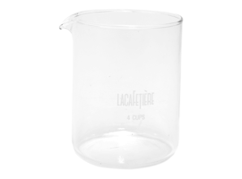

**12.** In the beaker below draw a labelled diagram of a carbon dioxide molecule (CO2). (2 marks)



**13.** In the beaker below draw and label a diagram a mixture of one N2 molecule and two O2 molecules. (2 marks)



**14.** Fill in the table below. (10 marks)

|  |  |
| --- | --- |
| **Element** | **Symbol** |
| Helium |  |
|  | Be |
| Carbon |  |
|  | P |
|  | K |
| Calcium |  |
|  | Li |
|  | B |
| Silicon |  |
|  | S |
|  | Cl |
| Oxygen |  |
|  | H |
| Nitrogen |  |
|  | F |
| Neon |  |
| Aluminium |  |
|  | Ar |
| Sodium |  |
|  | Mg |

**15a.** State the name given to the image below. (1 mark)

_____________________________________________________________________________________

**15b.** Shade in the elements that are non-metals on the image below. (1 mark)

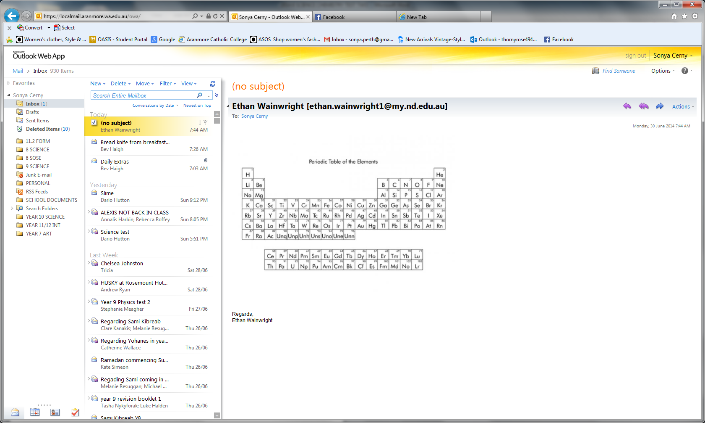

**16.** Fill in the missing words. (1 mark)

Oil is ______________________ with water. This means that the oil does not _________________ with the water.